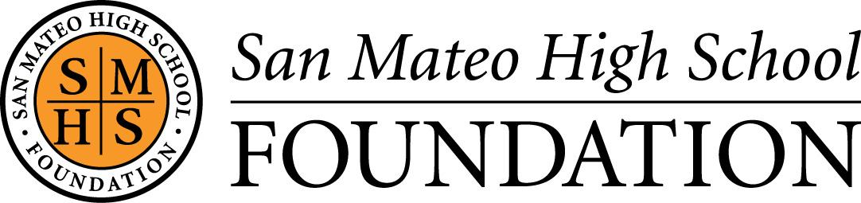

15TH ANNUAL BEARCAT BENEFIT
That 70’s Party

Saturday, October 26, 2019

BEARCAT BENEFIT AUCTION DONATION FORM

PLEASE PRINT YOUR NAME AND/OR COMPANY NAME EXACTLY AS IT SHOULD APPEAR IN OUR PROGRAM
BOOK AND PUBLICITY MATERIALS

Donor Name(s) ___________________________________________________________________ Date Submitted ______________________
Address _____________________________________________________________________________________________________________________
City _______________________________________________________________ State _______ Zip Code ______________________________
Contact Name _______________________________________________________________________________________________________________
E-mail ____________________________________________________________ Phone ________________________________________________
Please check: ☐Current SMHS Parent ☐Alumni SMHS Parent ☐Faculty/Staff ☐Merchant ☐Friend of SMHSF
(Due to our printing deadline, all donor forms received by 10/5/19 will be listed in the Program Book)
ITEM DESCRIPTION ________________________________________________________________________________________________________
_________________________________________________________________________________________________________________________________
_________________________________________________________________________________________________________________________________
_________________________________________________________________________________________________________________________________
_________________________________________________________________________________________________________________________________

ITEM VALUE ___________________________ EXPIRATION DATE (if any) _______________________

PLEASE CHECK ALL THAT APPLY:
☐Tangible Item (Delivery to be arranged with contact listed above)
☐Gift Certificate Enclosed
☐Please create a gift certificate for this donation

Signature of Donor or Other Authorized Individual _________________________________________________________________

IMPORTANT:
The values set forth are provided only for tax compliance purposes. San Mateo High School Foundation (SMHSF) does not appraise or value property received as contributions and makes no representations or warranties as to the correctness, validity, or adequacy of such values, and in accepting this receipt the donor releases and holds SMHSF harmless respecting any such valuations, and their correctness, validity or adequacy for tax or other purposes. No valuations are provided for contribution of time or services, which are generally non-deductible. For inventory items, no valuation can exceed the donor’s adjusted basis in the property, and for other items a deduction is generally equal to the fair market value of the property at the time of the contribution. SMHSF recommends that the donor seek independent legal or tax advice with respect to deductibility and amount of the contribution and the valuation through an independent appraisal or otherwise of the fair market value of the property contributed. By signing this form, donor provides permission to the SMHSF to use in its sole discretion any and all logos, trademarks, links to website(s), photographs or any other information provided to SMHSF for any advertising or promotional means, including but not limited to website, press materials and program book.

Please keep a copy for your records. Thank you for your donation!

San Mateo High School Foundation
506 North Delaware Street • San Mateo, CA 94401
• www.smhsf.org • info@smhsf.org • TAX ID Number: 20-0027218

